**“Freezy” the Snowman**

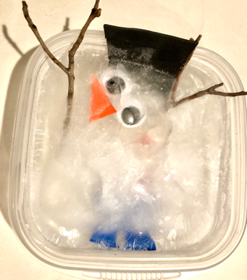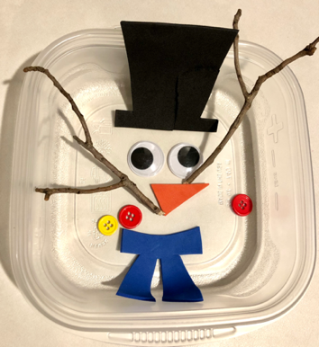

Use the templates below to cut out felt shapes for your “melting snowman”

Materials:

* Felt (suggested colors: White (eyeballs), orange (nose), brown (stick arms) multi-colors for buttons, scarf and hat.
* Scissors
* Markers
* Disposable food storage container (any size)
* Water

Directions:

* Using the templates provided below, cut 2 eyeballs, 3 buttons, 1 nose, 1 scarf, 1 hat, 2 stick arms.
* Draw pupils on the eyeballs, and any other details on the other pieces as desired
* Create a “snowman” by placing all the felt pieces on the bottom of a disposable food storage container.
* Note: Use googly eyes, a small carrot, real buttons, and small twigs for arms in lieu of the felt pieces.
* Fill the container with water. (Your felt pieces may float, that’s OK!)
* Place the container in a freezer (or outside if it’s below freezing) until the water has frozen to a solid block of ice.
* Remove “Freezy” from the freezer and see how long it takes for him to melt. You could us a stopwatch/timer to see how long it takes. Family members can make “predictions” about how long it will take for him to melt. See if you can find ways to “speed” up the melting process. Talk about concepts such as heat, freeze, cold, melt.

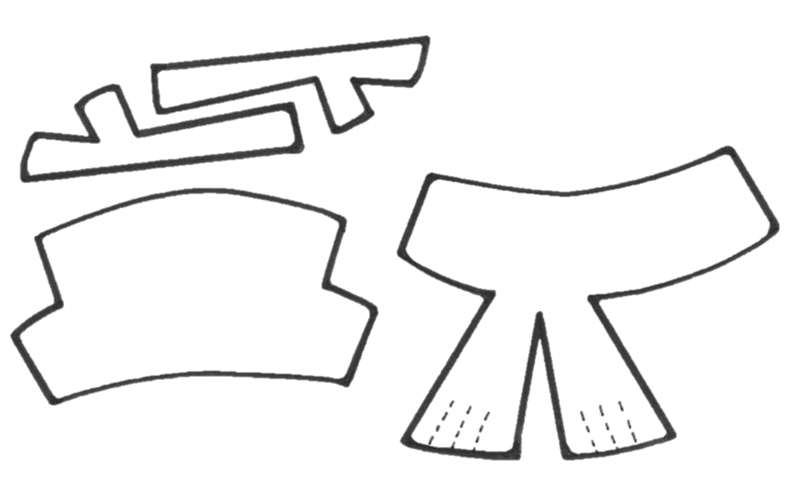

STICK ARMS

EYEBALLS

BUTTONS

NOSE

SCARF

HAT